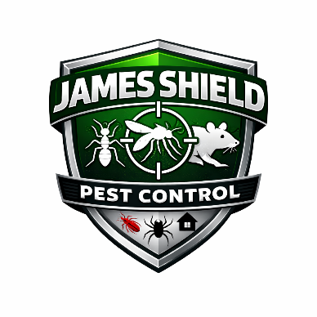
James Shield Pest Control
Family and Medical Leave Act (FMLA) Policy

1. Purpose
The purpose of this policy is to comply with the federal Family and Medical Leave Act (FMLA) and to provide eligible employees with job-protected leave for qualifying family and medical reasons.

2. Scope
This policy applies to all employees of James Shield Pest Control who meet FMLA eligibility requirements and who work at locations covered under the Act.

3. Eligibility
An employee is eligible for FMLA leave if they:
- Have worked for the Company for at least 12 months (not required to be consecutive);
- Have worked at least 1,250 hours during the 12 months immediately preceding the leave; and
- Work at a location where the Company employs 50 or more employees within a 75-mile radius.

4. Basic Leave Entitlement
Eligible employees may take up to 12 workweeks of unpaid, job-protected leave in a 12-month period for one or more of the following reasons:
- The birth of a child and to bond with the newborn;
- Placement of a child for adoption or foster care;
- To care for a spouse, child, or parent with a serious health condition;
- The employee’s own serious health condition that makes them unable to perform essential job functions;
- Qualifying exigencies arising from a family member’s covered military service.

5. Military Caregiver Leave
Eligible employees may take up to 26 workweeks of leave in a single 12-month period to care for a covered servicemember with a serious injury or illness.

6. Definition of Serious Health Condition
A serious health condition generally involves:
- Inpatient care; or
- Continuing treatment by a healthcare provider.
Additional definitions will follow federal FMLA regulations.

7. 12-Month Measurement Period
The Company uses a rolling 12-month period measured backward from the date an employee uses FMLA leave to determine the available leave entitlement.

8. Substitution of Paid Leave
FMLA leave is unpaid; however:
- Employees may elect, or the Company may require, substitution of accrued paid leave (such as Vacation or Sick Leave) during FMLA leave.
- Paid leave will run concurrently with FMLA leave.

9. Benefits During Leave
During FMLA leave:
- The Company will maintain group health insurance coverage under the same terms as if the employee had continued working.
- The employee remains responsible for their portion of premium payments.
Failure to return to work after FMLA leave may require repayment of employer-paid premiums, unless due to circumstances beyond the employee’s control.

10. Notice Requirements
10.1 Foreseeable Leave
Employees must provide at least 30 days’ advance notice when the need for leave is foreseeable.
10.2 Unforeseeable Leave
When 30 days’ notice is not possible, employees must provide notice as soon as practicable.
Employees must follow normal call-in procedures unless unusual circumstances prevent them from doing so.

11. Medical Certification
The Company may require medical certification supporting the need for leave.
- Certification must be returned within 15 calendar days.
- Recertification may be required as permitted by law.
- Failure to provide certification may result in denial of FMLA protection.

12. Intermittent Leave
FMLA leave may be taken intermittently or on a reduced schedule when medically necessary.
For birth or placement of a child, intermittent leave requires Company approval.

13. Job Protection
Upon return from FMLA leave, the employee will be restored to:
- The same position held before leave; or
- An equivalent position with equivalent pay, benefits, and working conditions.

14. Key Employees
Certain highly compensated “key employees” may be denied reinstatement if restoration would cause substantial economic injury to the Company, as permitted by law.

15. Non-Retaliation
James Shield Pest Control prohibits interference with, restraint of, or retaliation against any employee for exercising rights under FMLA.

16. Administration
The Company reserves the right to interpret and administer this policy in accordance with federal regulations and may amend it as necessary to comply with legal requirements.

Approved By: ___________________________
Effective Date: ________________________

